# CIS 3145 Class Notes: Text Chapter 19

## Database and MySQL setup

**Objectives**

* Describe a relational Database, Table, and column
* Describe the SQL query statement
* Use the SQL statement to select, add, update or delete data in a table
* Describe the MySQL database
* Be able to set the CLASSPATH environment variable for using the MySQL database
* Be able to connect and run SQL statements and scripts in the MySQL database
* Be able to run SQL scripts for the MySQL database from the prompt

**Relational Databases**

The relational database management system (RDBMS) helps organize data and reduces redundancy in the data storage layer. It is an efficient way to store data and reduces logical errors in reporting data.

Data is stored in **tables** that have rows and columns of data. Tables are **subject** oriented.

Each **row** of data in a table describes an individual.

Each **column** in a table holds a variable (or attribute) of the individual.

Just like in a programming language there are **data** **types** for databases: 2 examples

VARCHAR for String

DOUBLE for double

INT for integer

**SQL Statements**

The **select** statement is the most common statement used with a database. This statement gets data from the database. The SELECT and FROM clauses of the statement are required, while the WHERE and ORDER BY clauses are optional. These are part of the **Data Manipulation Language (DML)**.

SELECT column

FROM table

[WHERE criteria]

[ORDER BY column]

Other SLQ statements will insert, update, and delete data.

INSERT INTO table

VALUES (value list)

UPDATE table

SET column = ‘expression’

[WHERE condition]

DELETE table

[WHERE condition]

**MySQL Database**

The **MySQL** database is an open source database. Some advantages of using MySQL is that it is free to use (mostly), fast, easy to use and works on most operating systems. It is very popular and is used in many businesses. It is part of the open source LAMP stack: **L**inux operating system, **A**pache HTTP server, **M**ySQL RDBMS, and **P**HP programming language for web pages.

MySQL is a fully functional RDBMS which uses standard SQL. It can connect to multiple programming languages, with standard security, and referential integrity for transaction processing.

We are using **MySQL workbench** as a graphical user interface (GUI) IDE for managing databases. There are windows in the workbench to type in SQL statements and to view the content of the database. MySQL can be manipulated through the command line but using a GUI IDE is more convenient.

MySQL and the workbench are installed on the computers in the Admin 250 classroom.

An **SQL script** is a file that holds SQL commands in a text format. These are useful if we want to re-create a database in its original format. The CREATE DATABASE, CREATE TABLE, and DROP commands are part of the **Data Definition Language (DDL)**, while GRANT is part of the **Data Control Language (DCL).**

To use the **MySQL** **database** and **workbench** both components need to be installed. Both are part of a MySQL Installer package for Windows programs found at this website: <https://dev.mysql.com/downloads/windows/installer/5.7.html>

As the MySQL database server is being installed make sure to note the password that is asked for. The book recommends using the password sesame for the root user which is fine for educational purposes. I also recommend you select the setting to have MySQL automatically start as a service. Otherwise you can go to “Administrative Tools” and use the “Services” option to start the MySQL services.

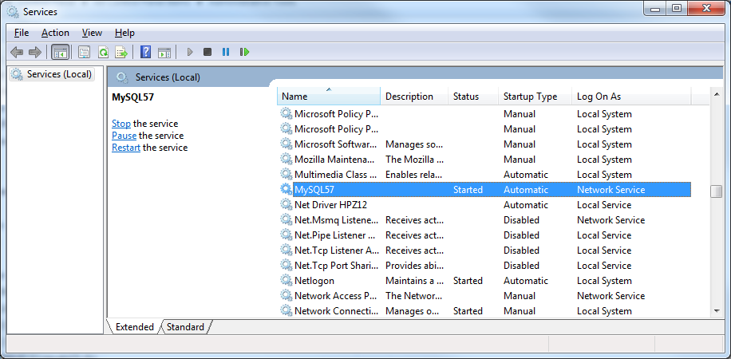

**If the MySQL server is turned off these error messages occur.**

murach.db.DBException: com.mysql.jdbc.exceptions.jdbc4.CommunicationsException: Communications link failure

The last packet sent successfully to the server was 0 milliseconds ago. The driver has not received any packets from the server.